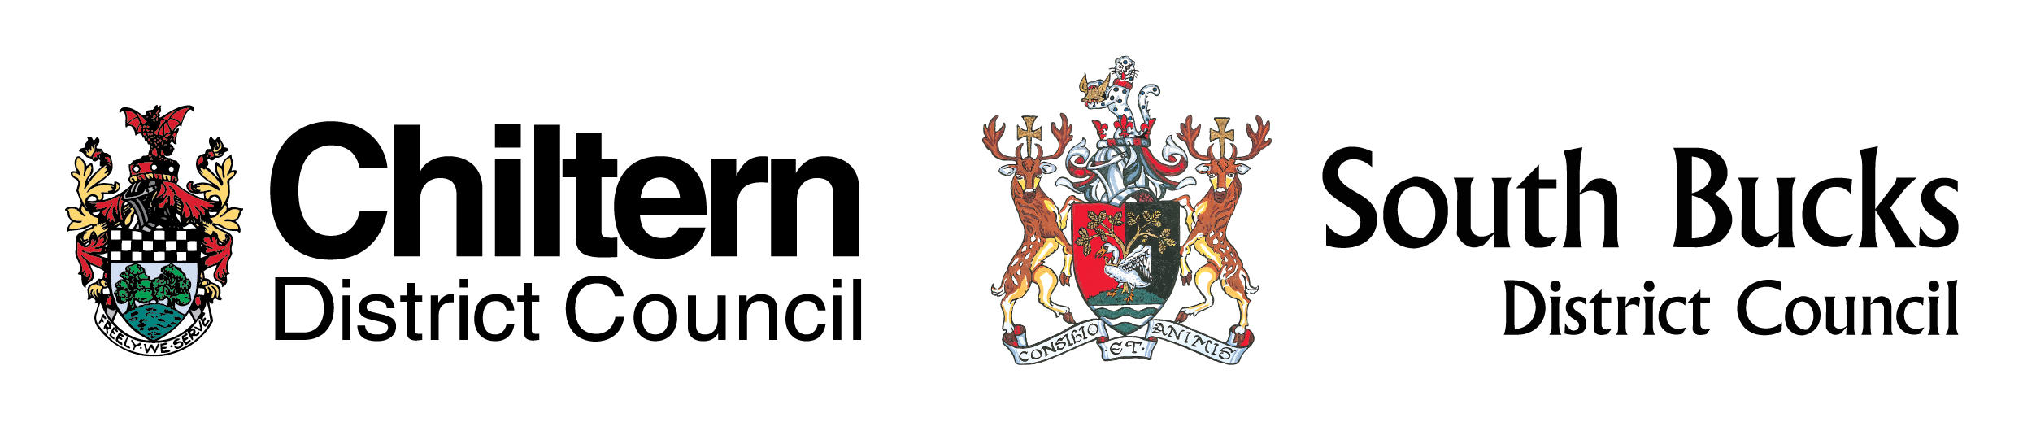
Chiltern and South Bucks Local Plan
Initial (Regulation 18) Consultation Inc. Issues and Options Response Form

This is YOUR chance to get involved in the Local Plan process and state what YOU think the plan should address or include as well as provide your views on the Issues and Options identified. The Local Plan Consultation Document asks 17 questions, however please do not feel limited by these questions and include any points you think are relevant.

This form has two parts:

PART A respondent (your) details, which will not be published; and

PART B for comments, which will be publically available. If needed continue your comments on separate sheets.

Please note responses received as part of this consultation cannot be treated as confidential. All comments that have been made will be made public and included in Council documents displayed on the Councils’ websites. However, no personal details, other than the respondent’s name, will be made public. Responses submitted to Chiltern or South Bucks District Council will be processed and shared between the two Councils. Chiltern District Council and South Bucks District Council are the Data Controllers for the purposes of the Data Protection Act 1998.

This form is also accompanied by an Equality Monitoring Form. Respondents are encouraged to complete this as the data will be used to tailor and improve future consultations to ensure we reach and enable responses from all parts of the community. Individual data collected from this Monitoring Form will remain confidential with only summary results being published.

Please return your completed forms to Chiltern District Council or South Bucks District Council by post or by email to:

The Planning Policy Team
Chiltern District Council
King George V House
King George V Road
Amersham
Bucks
HP6 5 AW
 | planningpolicy@chiltern.gov.uk | or | ldf@southbucks.gov.uk

All Consultation Responses must be received by 5 pm on 14th March 2016.

If you would like to discuss any matter relating to this consultation please contact a member of the Planning Policy Team during normal office hours on (01494) 586 678 or (01895) 837 210 or by the email addresses provided above.
PART A – PERSONAL DETAILS

Are you:

A resident An organisation Other (please specify)

Personal Details* |  |  | Agent’s Details (if applicable)
**Title | Mr
**First Name
**Last Name
Job Title
(if on behalf of an organisation)
Organisation
(if applicable)
**Address
Telephone Number
**Email Address
*if an agent is appointed, please complete only the title and name boxes and, if applicable, the organisation box but complete the full contact details for the agent.

**Mandatory fields if you wish to be added to the consultation database (see below).

Consultation Database
The Councils have a joint Planning Policy Consultation database used to keep individuals and organisations informed about Planning Policy Documents across both Council areas. Documents include: the Local Plan, Supplementary Planning Documents and Neighbourhood Plans, (please note some plans may not be applicable to your area).

Chiltern District Council and South Bucks District Council are the Data Controllers for the purposes of the Data Protection Act 1998. Individuals and organisations on the Planning Policy Consultation Database will only be contacted by the Councils in relation to the preparation and production of planning policy documents. The Councils will not publish the names of those individuals on the database but may publish names of statutory bodies and organisations at certain stages of the Local Plan process. Please indicate if you want to be added to the joint consultation database.

I agree with the above statement, please add my details (Part A) to the Chiltern and South Bucks Planning Policy Consultation Database.

Please note: if you are currently on either the Chiltern or South Bucks Planning Policy Consultation Database you will need to ‘opt-in’ to the new database (by ticking the box above) to continue receiving notifications.

PART B – RESPONSE

Please complete this section for comments you wish to make.
Please do not include any personal details that you do not want disclosed, as this section will be made publically available.

If you are answering any of the questions in the Consultation Document (i.e Questions 1 to 17) then please clearly state which parts/answers relate to which question(s). The questions are there as prompts but responses can relate to any matter you consider is relevant.

Continue on separate sheets if necessary.

Please also complete the Equality Monitoring Form.
Separate Sheet

Chiltern and South Bucks Local Plan
Equality Monitoring Form

Chiltern District Council and South Bucks District Council are committed to promoting equality, and will not place anyone at a disadvantage because of any aspect of their age, disability, ethnic origin, marital status, race, religion, gender or sexuality.

This monitoring form is designed to help the Councils understand which parts of the community respond and to improve future consultations.

The information you give us on this form is confidential. As it is a joint consultation between the two Councils, information will be processed and shared between the two Councils but only summary results will be published.

Should you have any questions about the information asked, please contact a member of the Planning Policy Team during normal office hours on (01494) 586 678 or (01895) 837 210 or by email: planningpolicy@chiltern.gov.uk or ldf@southbucks.gov.uk.

- How did you hear about this consultation? (Tick more than one if necessary)

Email/ Letter Twitter
Local Press Facebook
Council Website Word of mouth
Other (please state below)

- What is your Gender?

Male Female

- How old are you?

Under 15 | 15 - 19 | 20 - 24 | 25 - 29
30 - 34 | 35 - 39 | 40 - 44 | 45 - 49
50 - 54 | 55 - 59 | 60 - 64 | 65 - 69
70 - 74 | 75 - 79 | 80 - 84 | 85 or over

- Do you consider yourself to have a disability?

Yes No

- What is your ethnic group?

A White
English/Welsh/ Scottish/ Northern Irish/ British
Irish
Any other White (state below)

B Mixed / Multiple Ethnic Groups
White and Black Caribbean
White and Black African
White and Asian
Any other Mixed /multiple ethnic background, (state below)

C Asian / Asian British
Indian
Pakistani
Bangladeshi
Chinese
Any other Asian background, (state below)

D Black / African / Caribbean / Black British
African
Caribbean
Any other Black background, (state below)

E Gypsy or Irish Traveller
Gypsy
Irish Traveller

F Other Ethnic Groups
Any other ethnic group, (state below)

G Do not want to say

Thank you for taking the time to complete this monitoring form. Please also let us know if you have any ideas on how we can improve our consultation processes to ensure equality.

Available at www.chiltern.gov.uk/planning/localplan2014-2036 or www.southbucks.gov.uk/planning/localplan2014-2036

